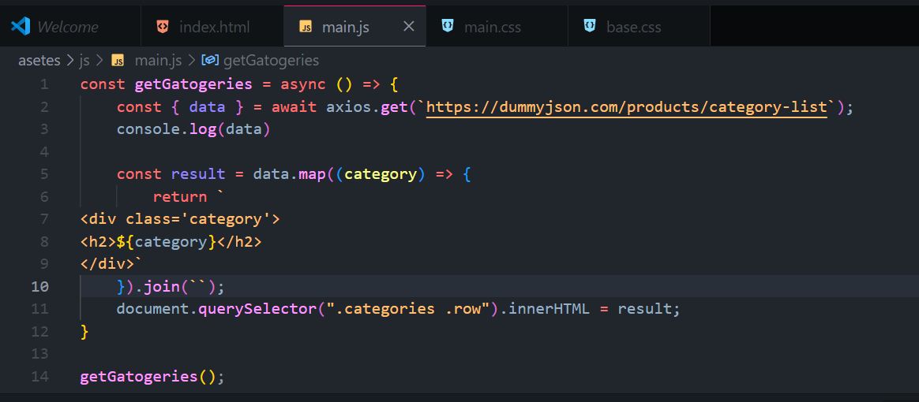

const getGatogeries = async () => {

    const { data } = await axios.get(`https://dummyjson.com/products/category-list`);

    console.log(data)

    const result = data.map((category) => {

        return `

<div class='category'>

<h2>${category}</h2>

</div>`

    }).join(``);

    document.querySelector(".categories .row").innerHTML = result;

}

getGatogeries();

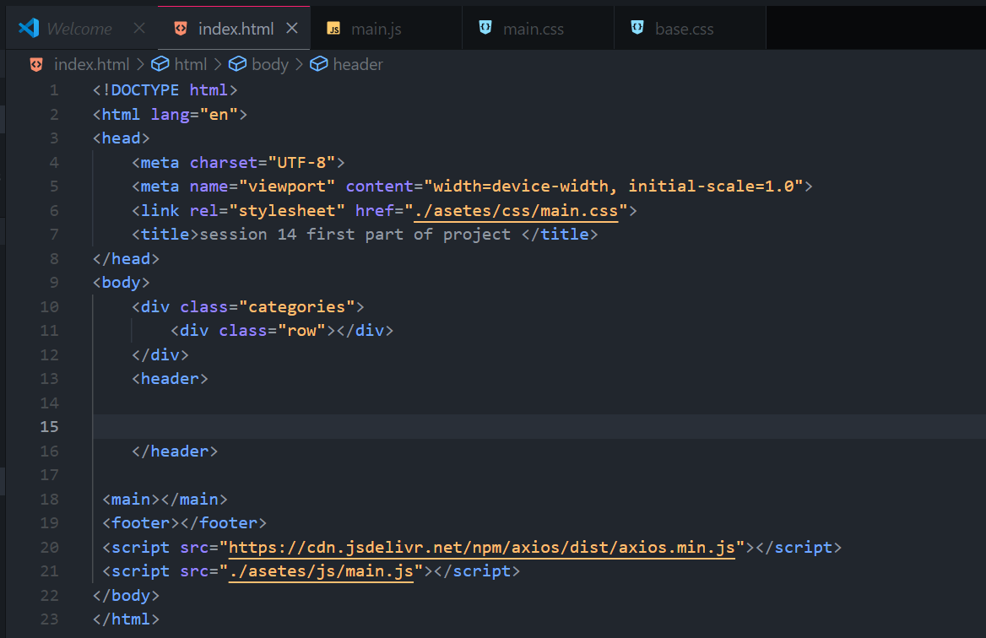

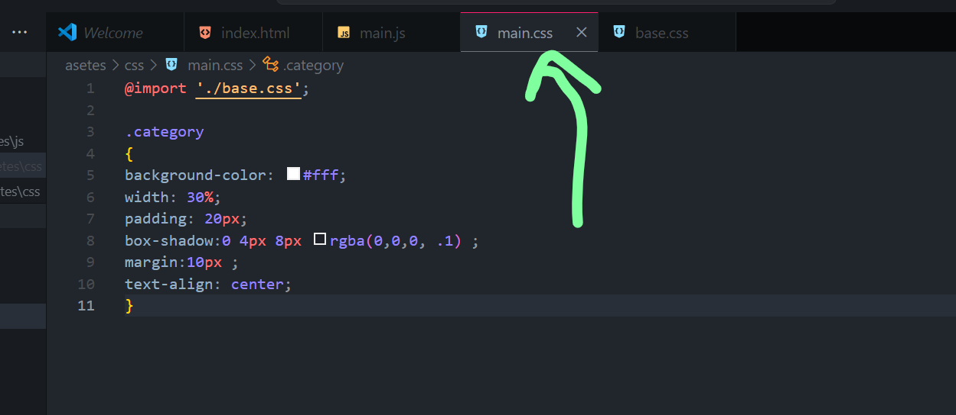

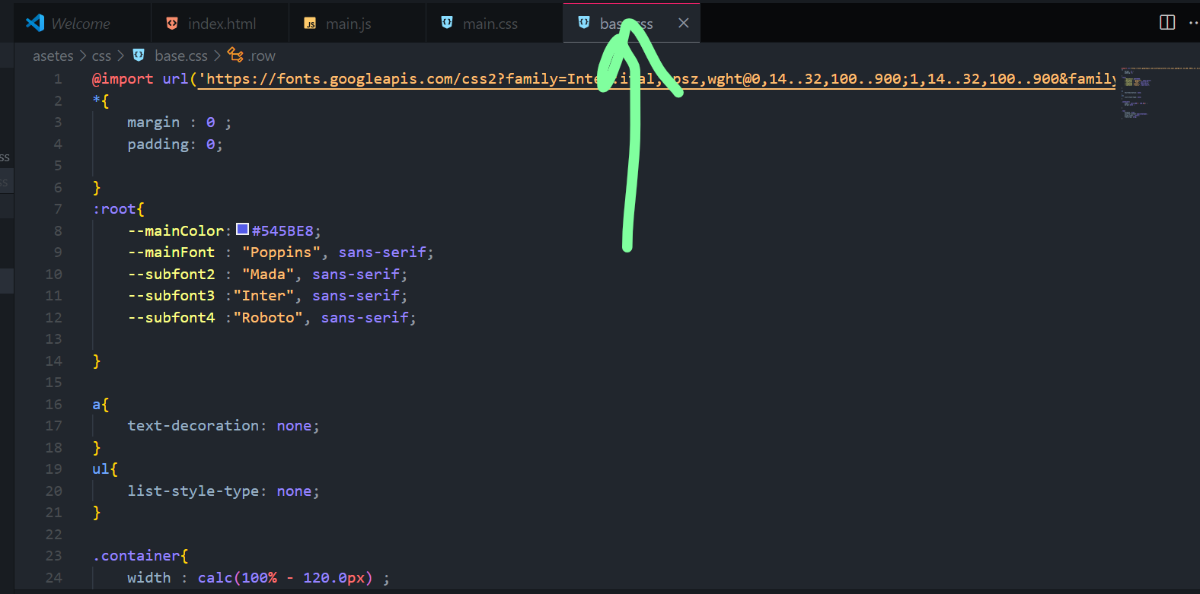

@import url('https://fonts.googleapis.com/css2?family=Inter:ital,opsz,wght@0,14..32,100..900;1,14..32,100..900&family=Mada:wght@200..900&family=Poppins:ital,wght@0,100;0,200;0,300;0,400;0,500;0,600;0,700;0,800;0,900;1,100;1,200;1,300;1,400;1,500;1,600;1,700;1,800;1,900&family=Roboto:ital,wght@0,100;0,300;0,400;0,500;0,700;0,900;1,100;1,300;1,400;1,500;1,700;1,900&display=swap');

*{

    margin : 0 ;

    padding: 0;

}

:root{

    --mainColor:#545BE8;

    --mainFont : "Poppins", sans-serif;

    --subfont2 : "Mada", sans-serif;

    --subfont3 :"Inter", sans-serif;

    --subfont4 :"Roboto", sans-serif;

}

a{

    text-decoration: none;

}

ul{

    list-style-type: none;

}

.container{

    width : calc(100% - 120.0px) ;

    margin:auto ;

}

.row{

    display :flex;

    justify-content:space-between ;

    align-items: center;

    flex-wrap: wrap;

}

Result as shown bellow

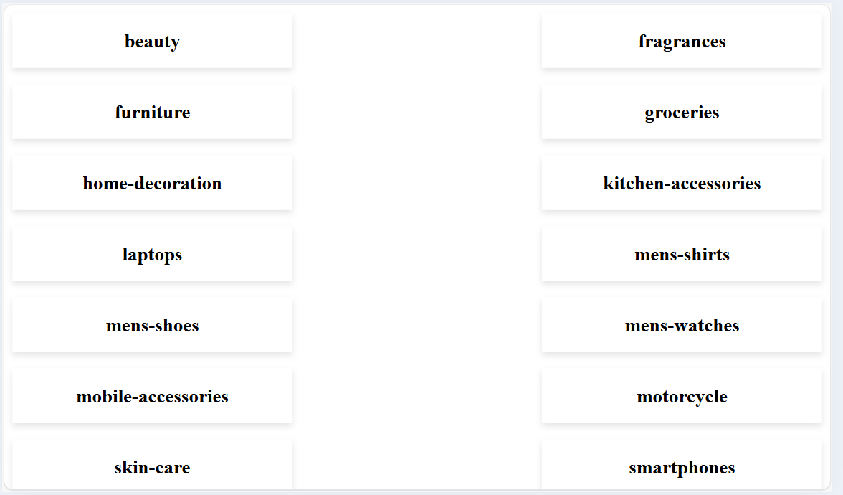

Now with another way

Function get then return data

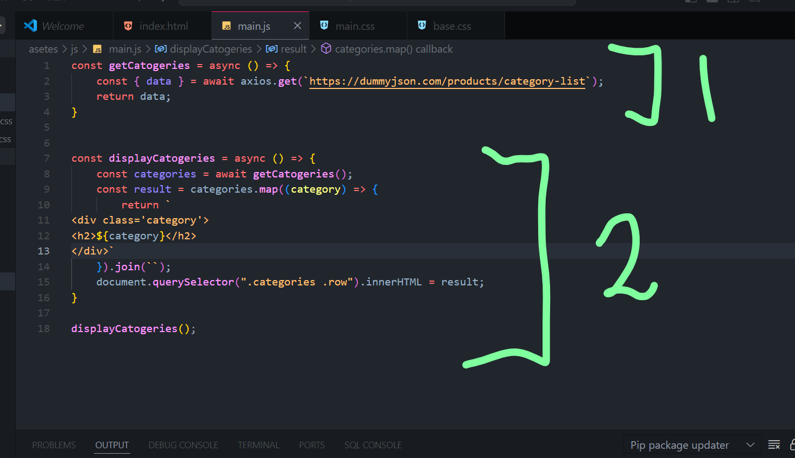

Same result



Now if I need do drop down

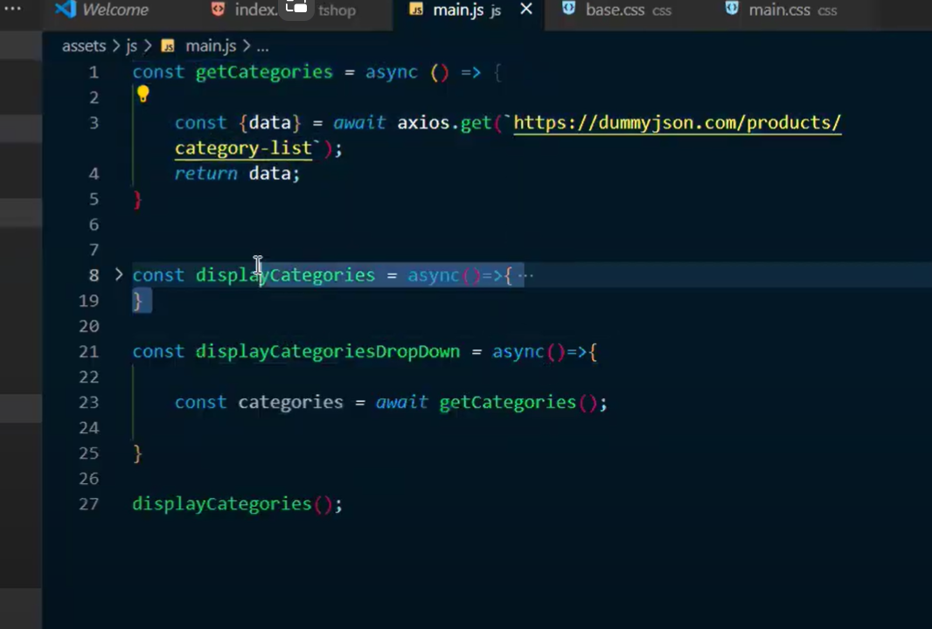

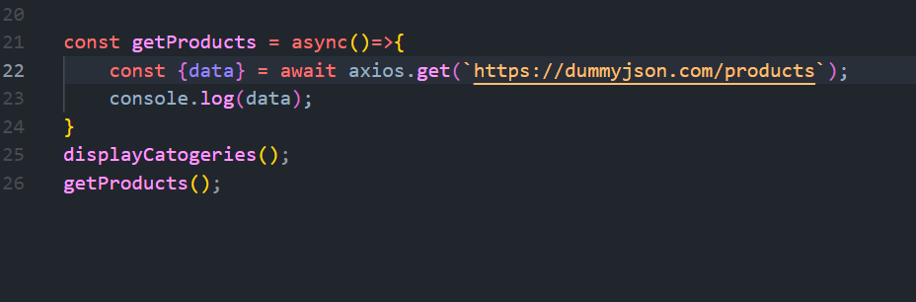

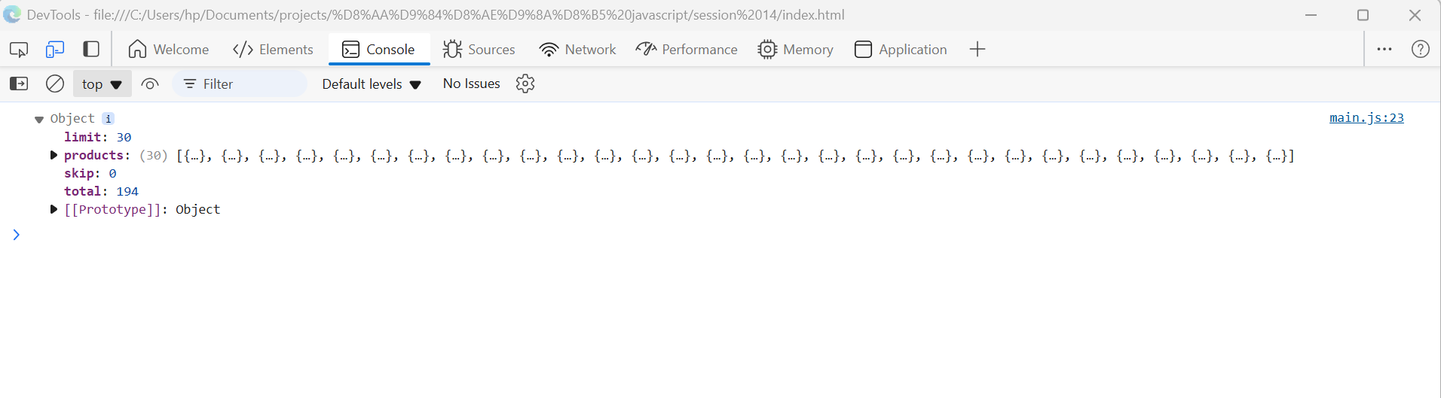

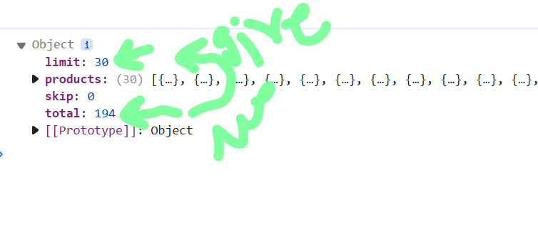

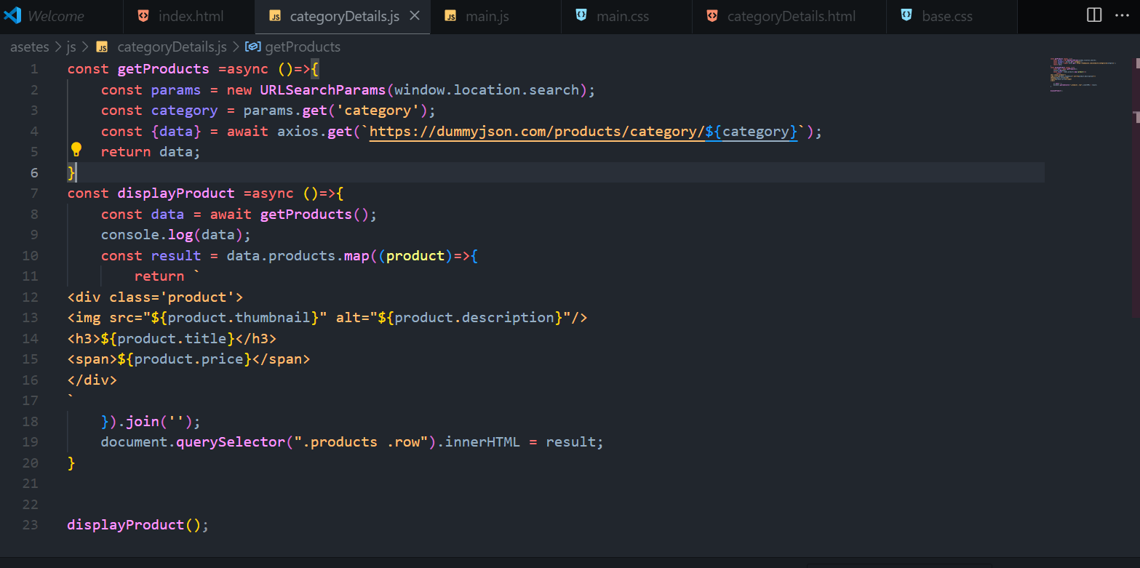

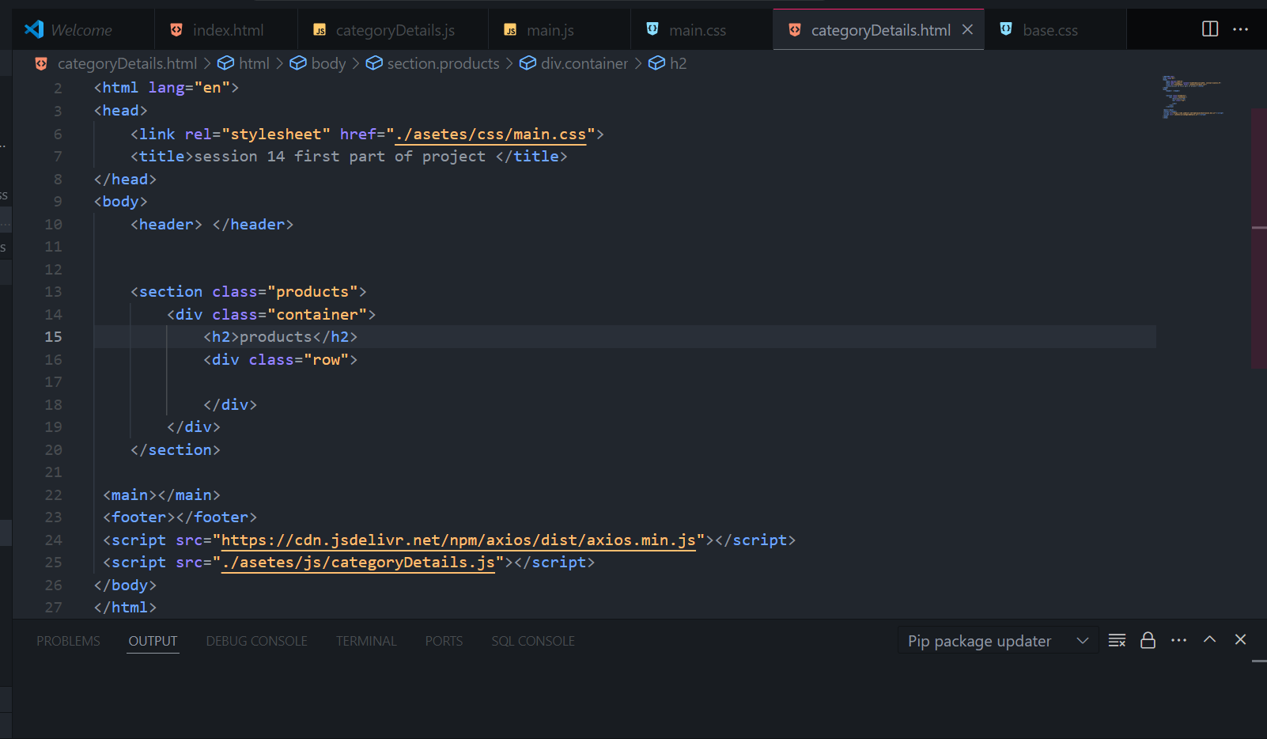

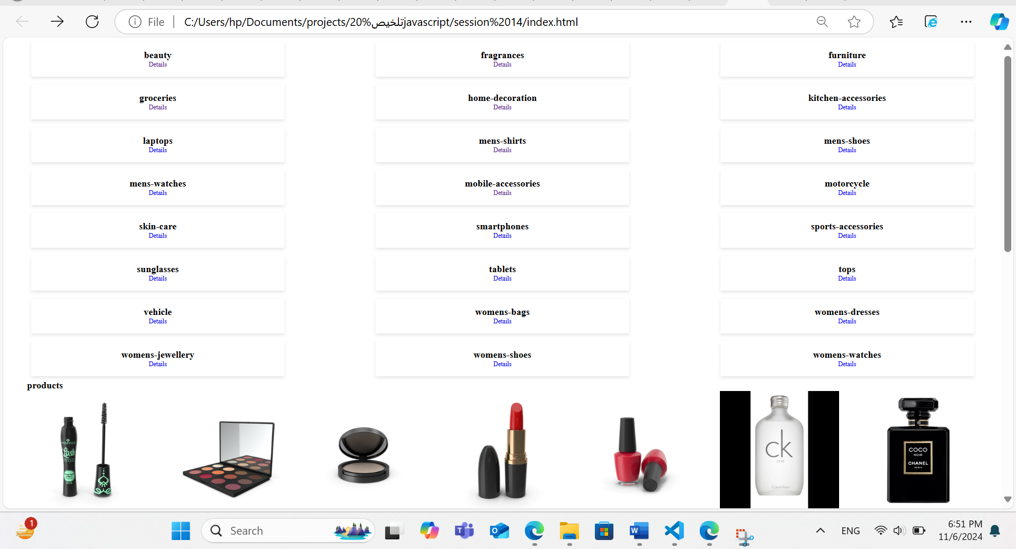

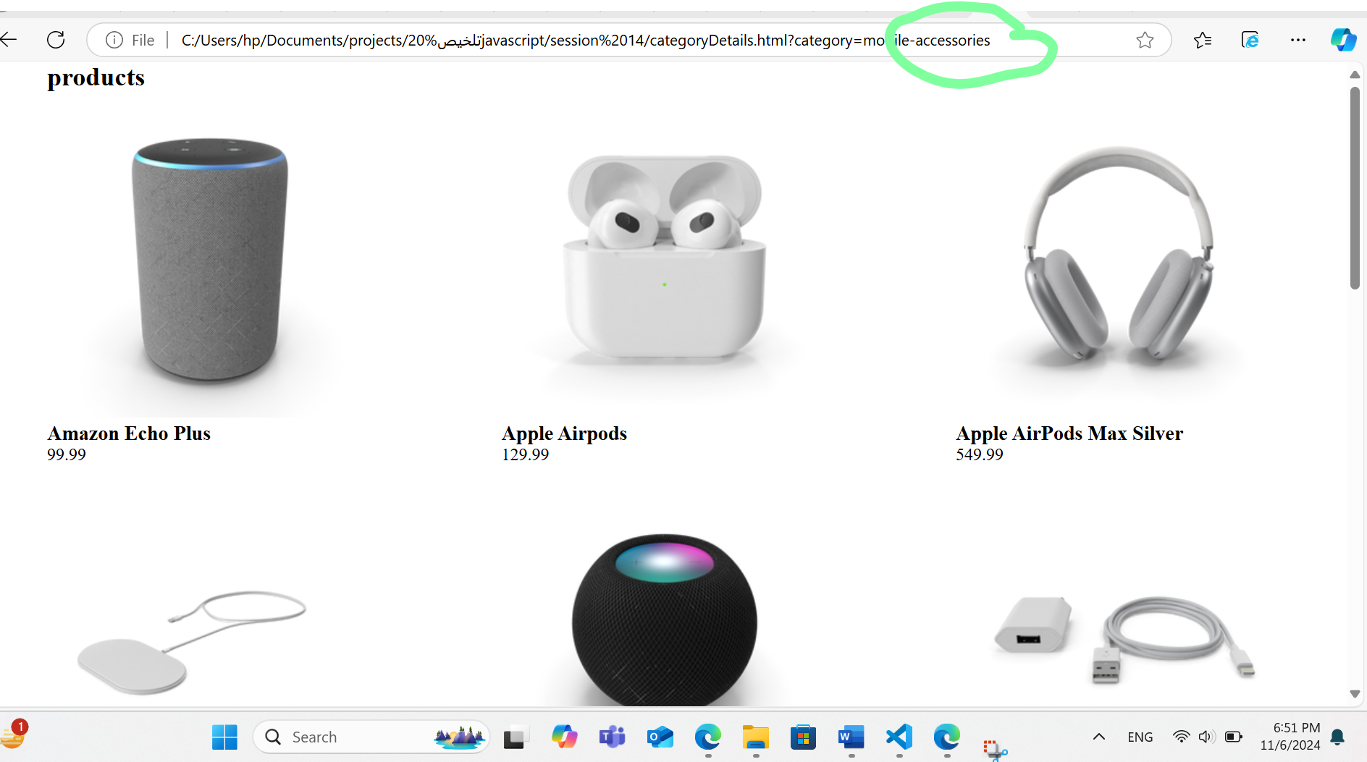

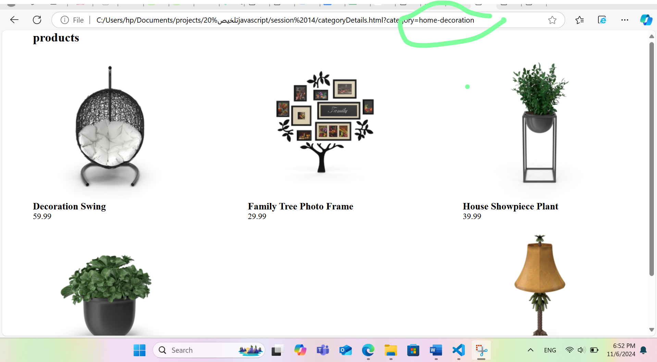

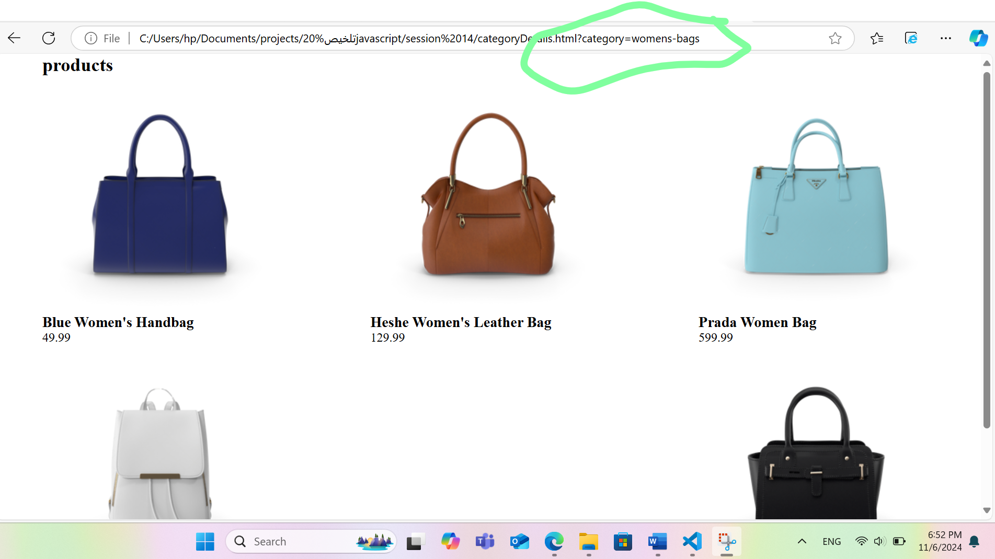

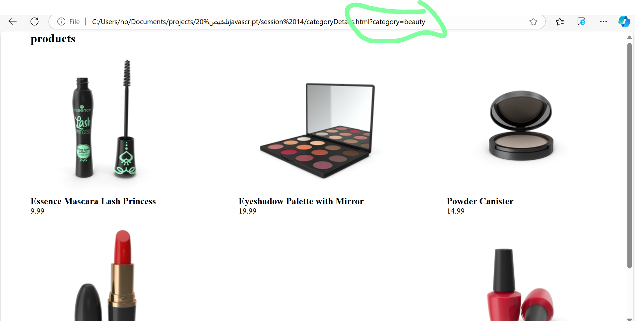

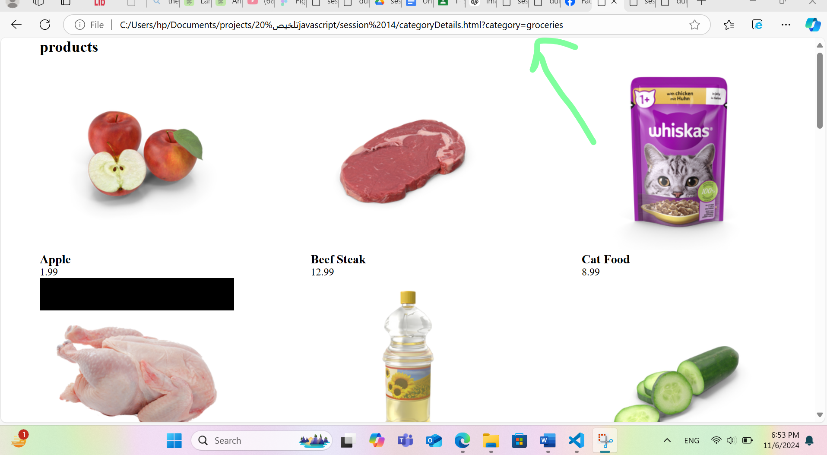

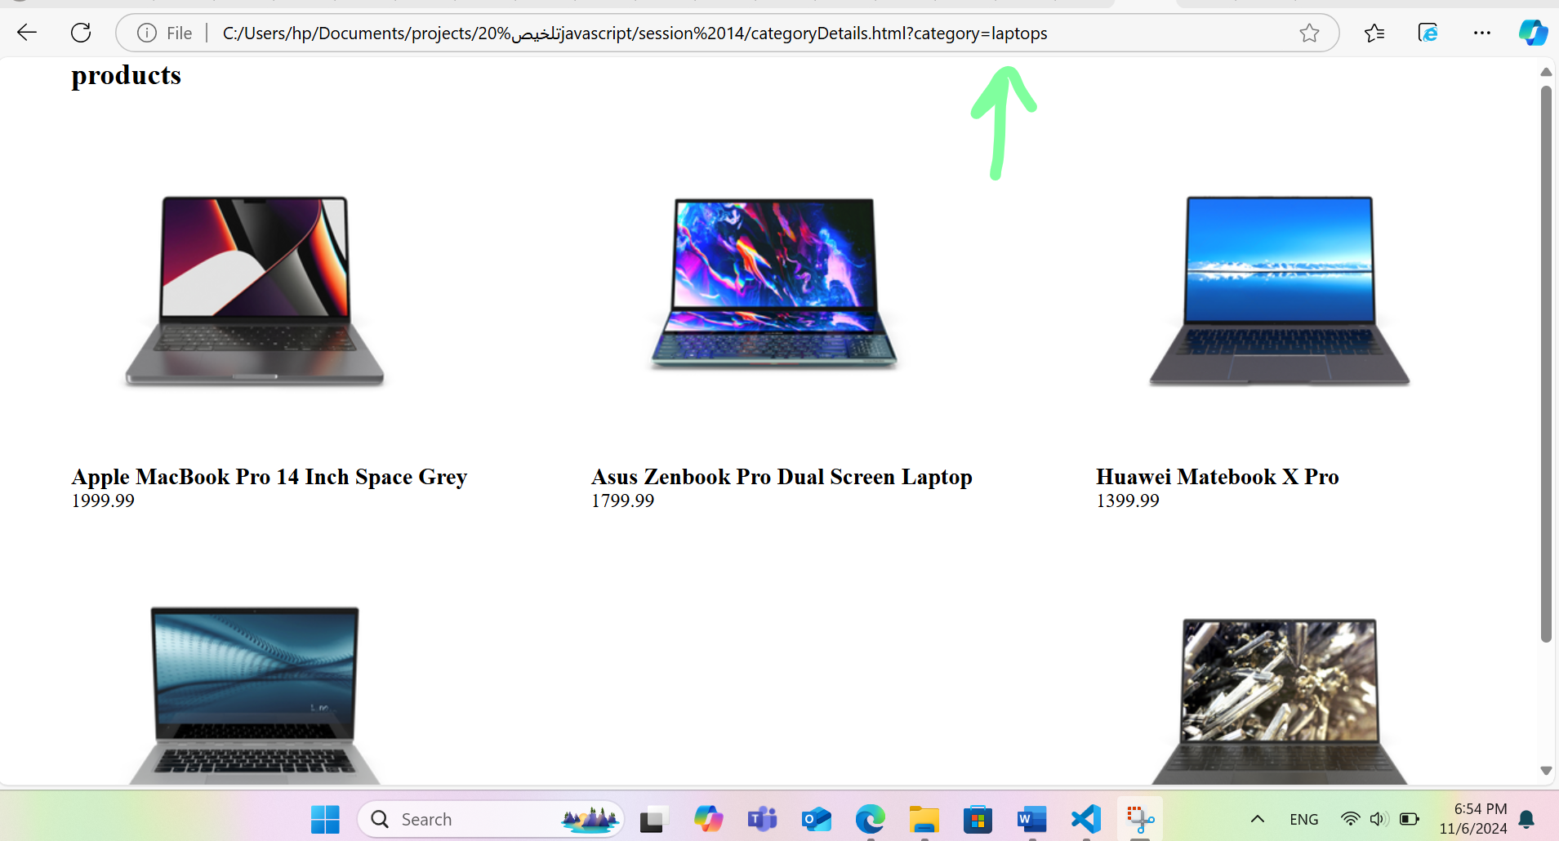

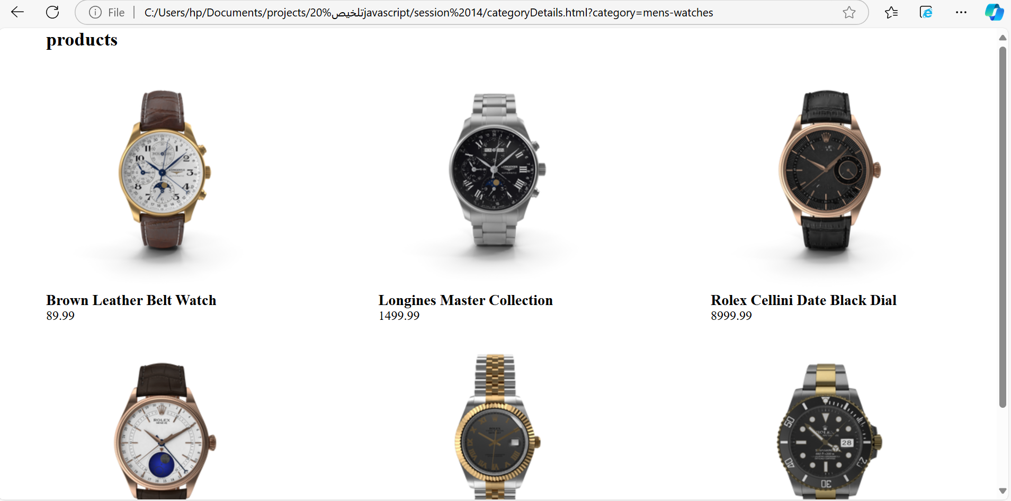

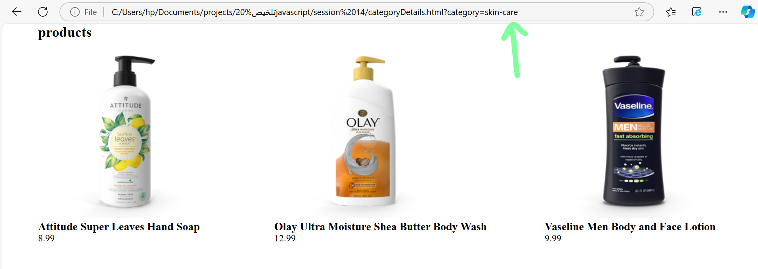

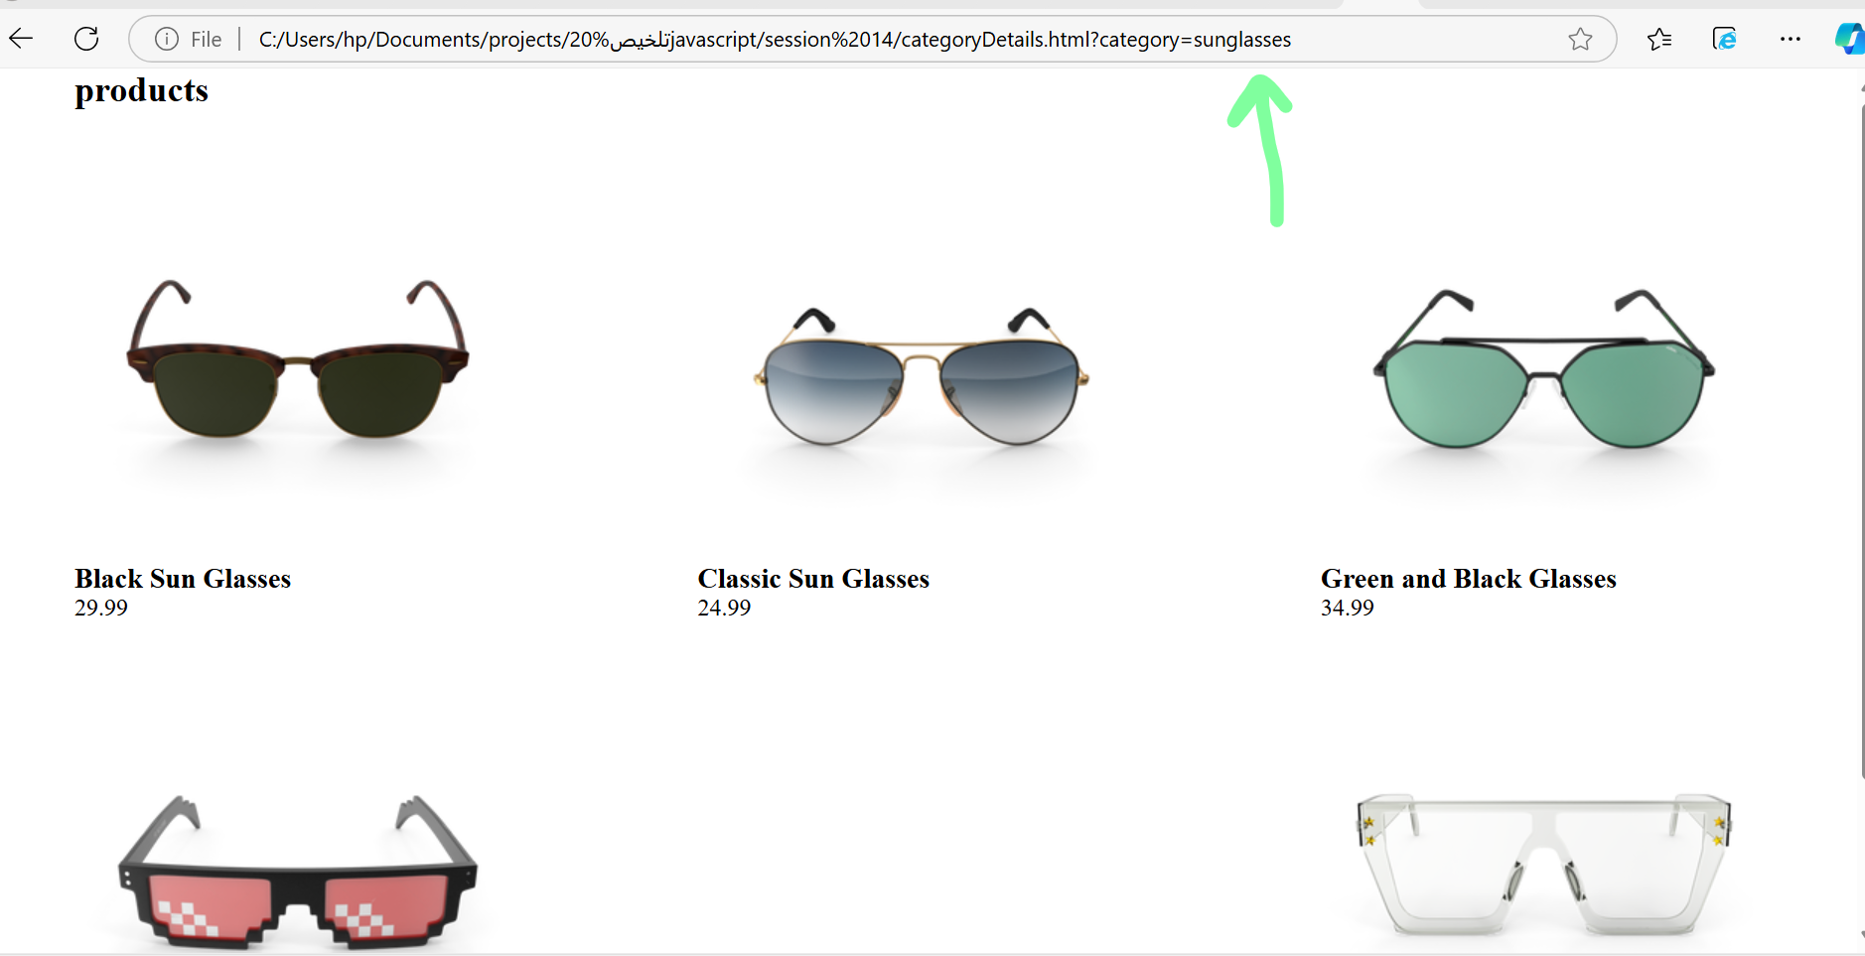

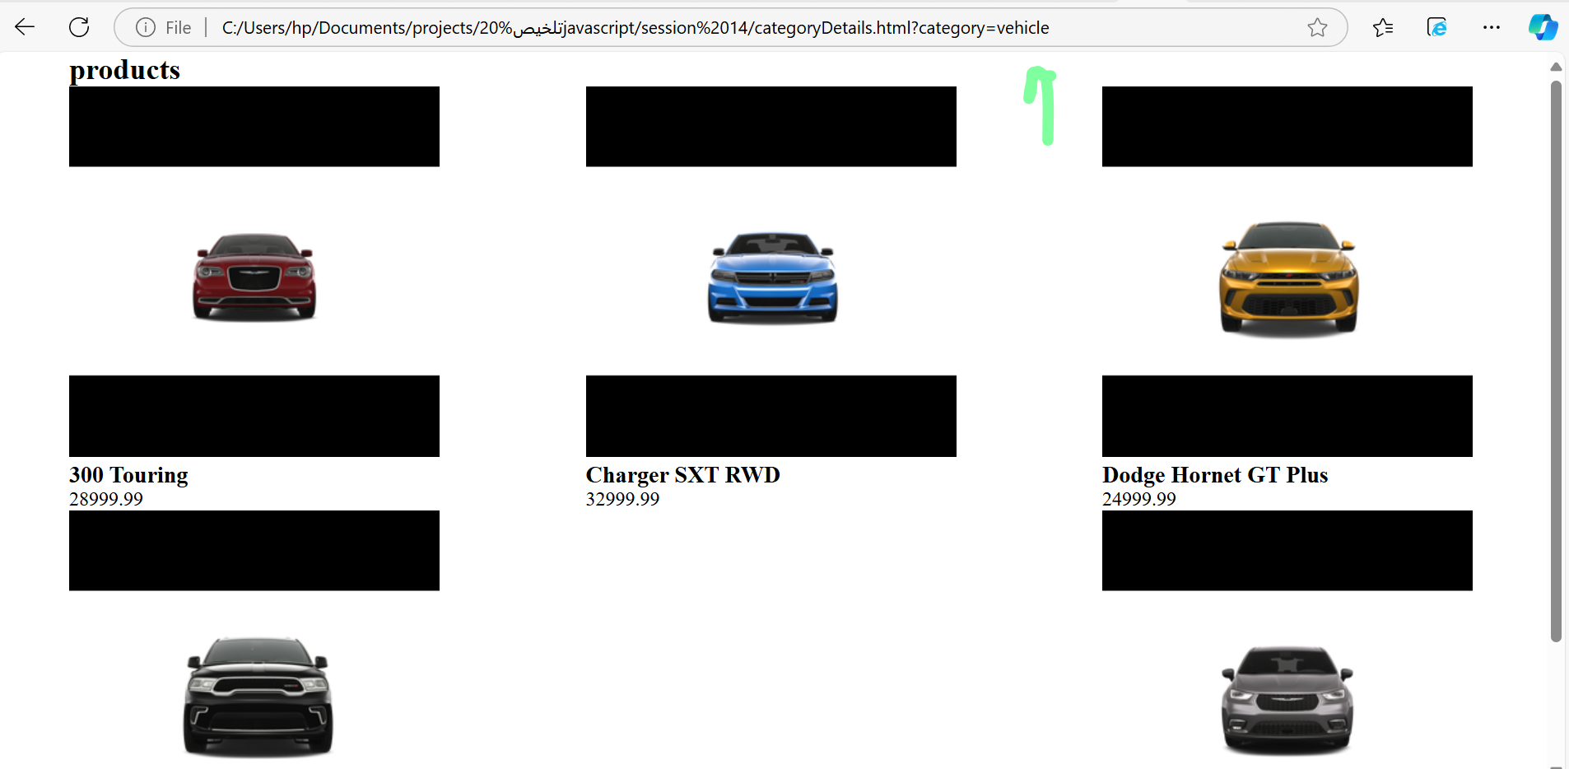

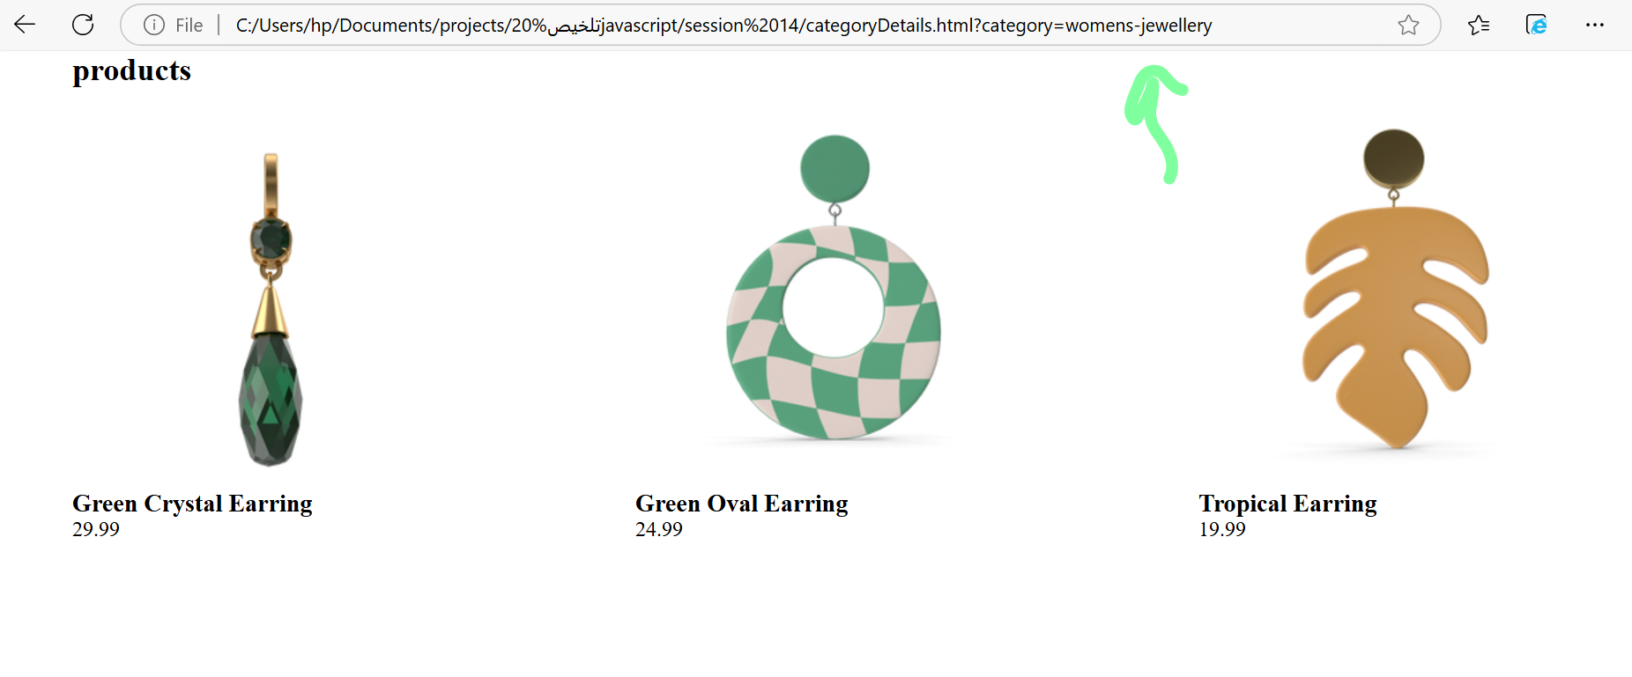 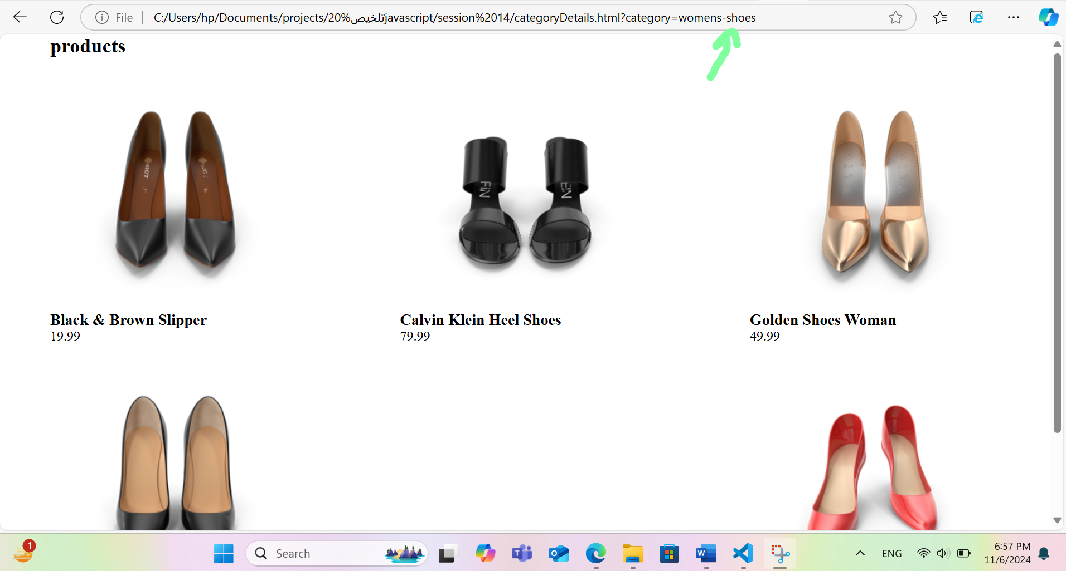

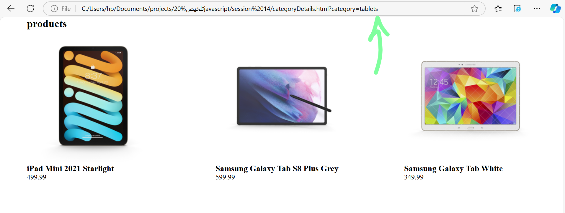

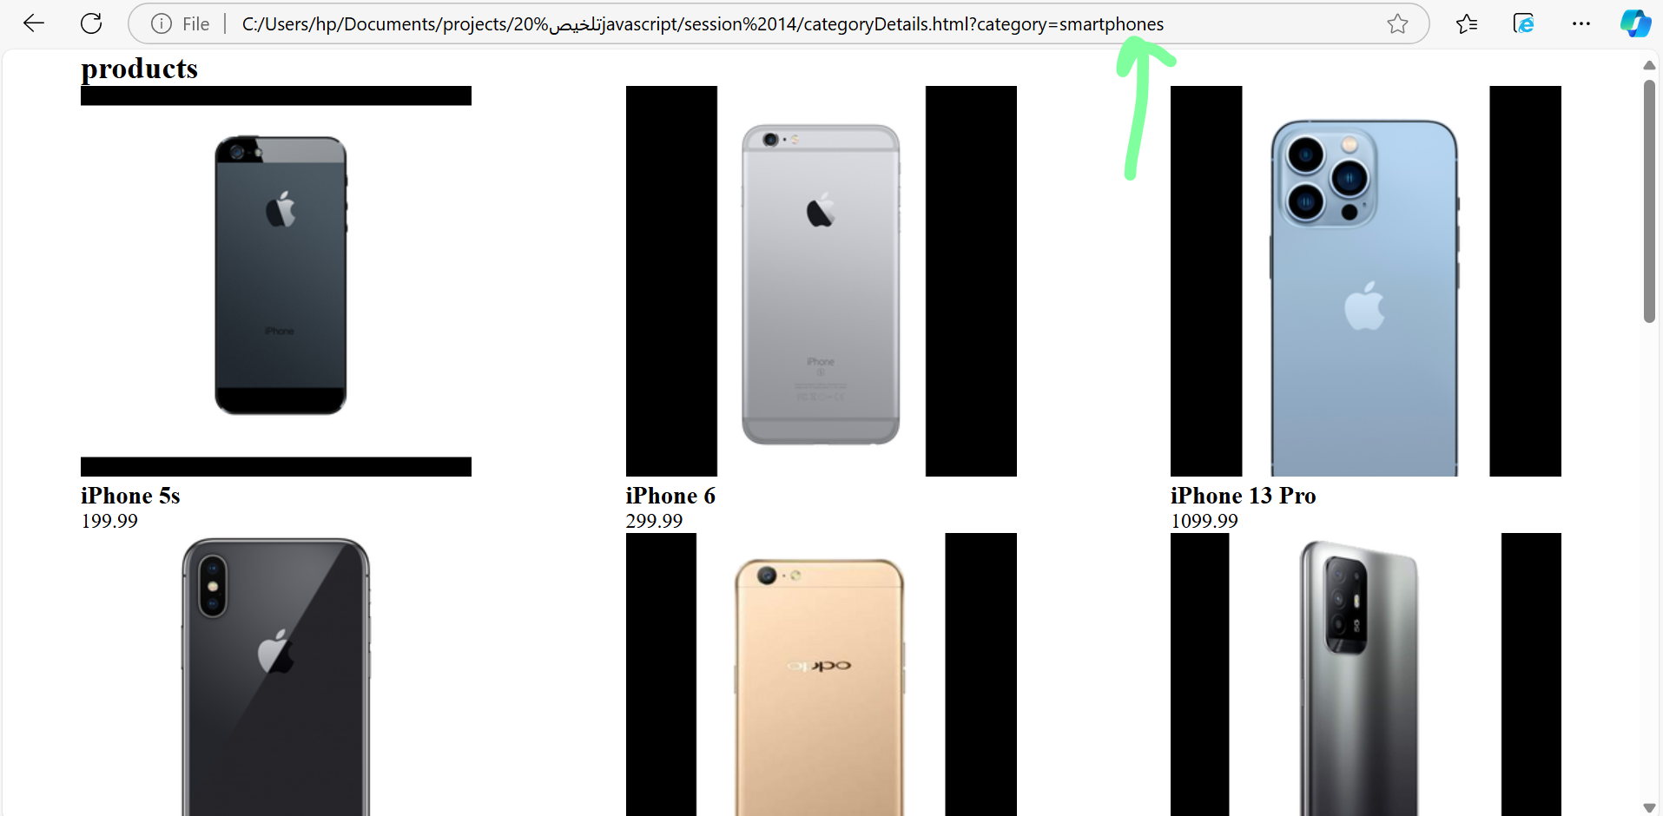

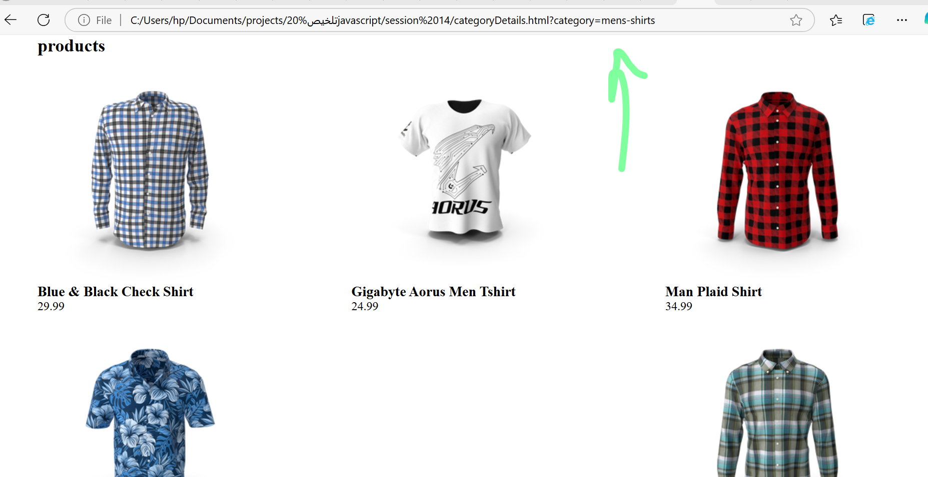

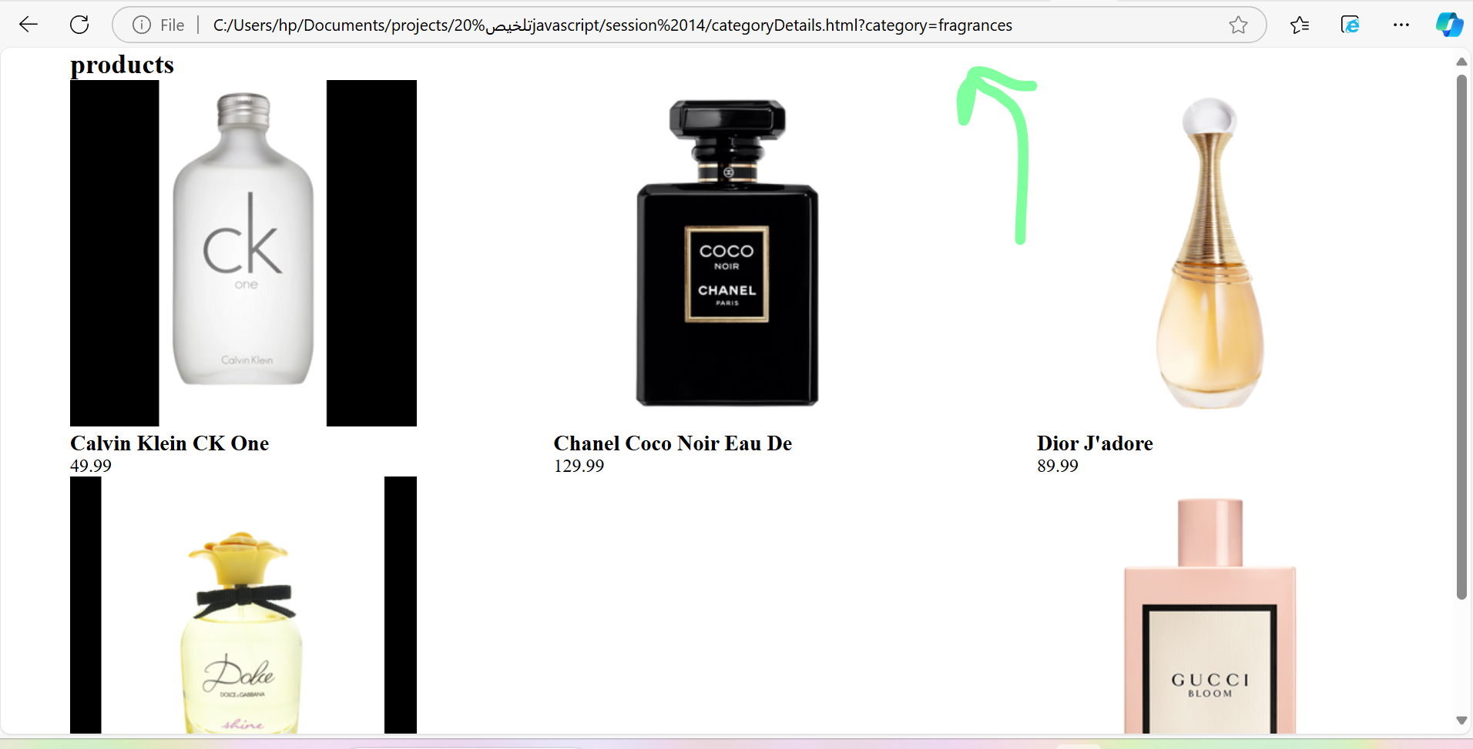

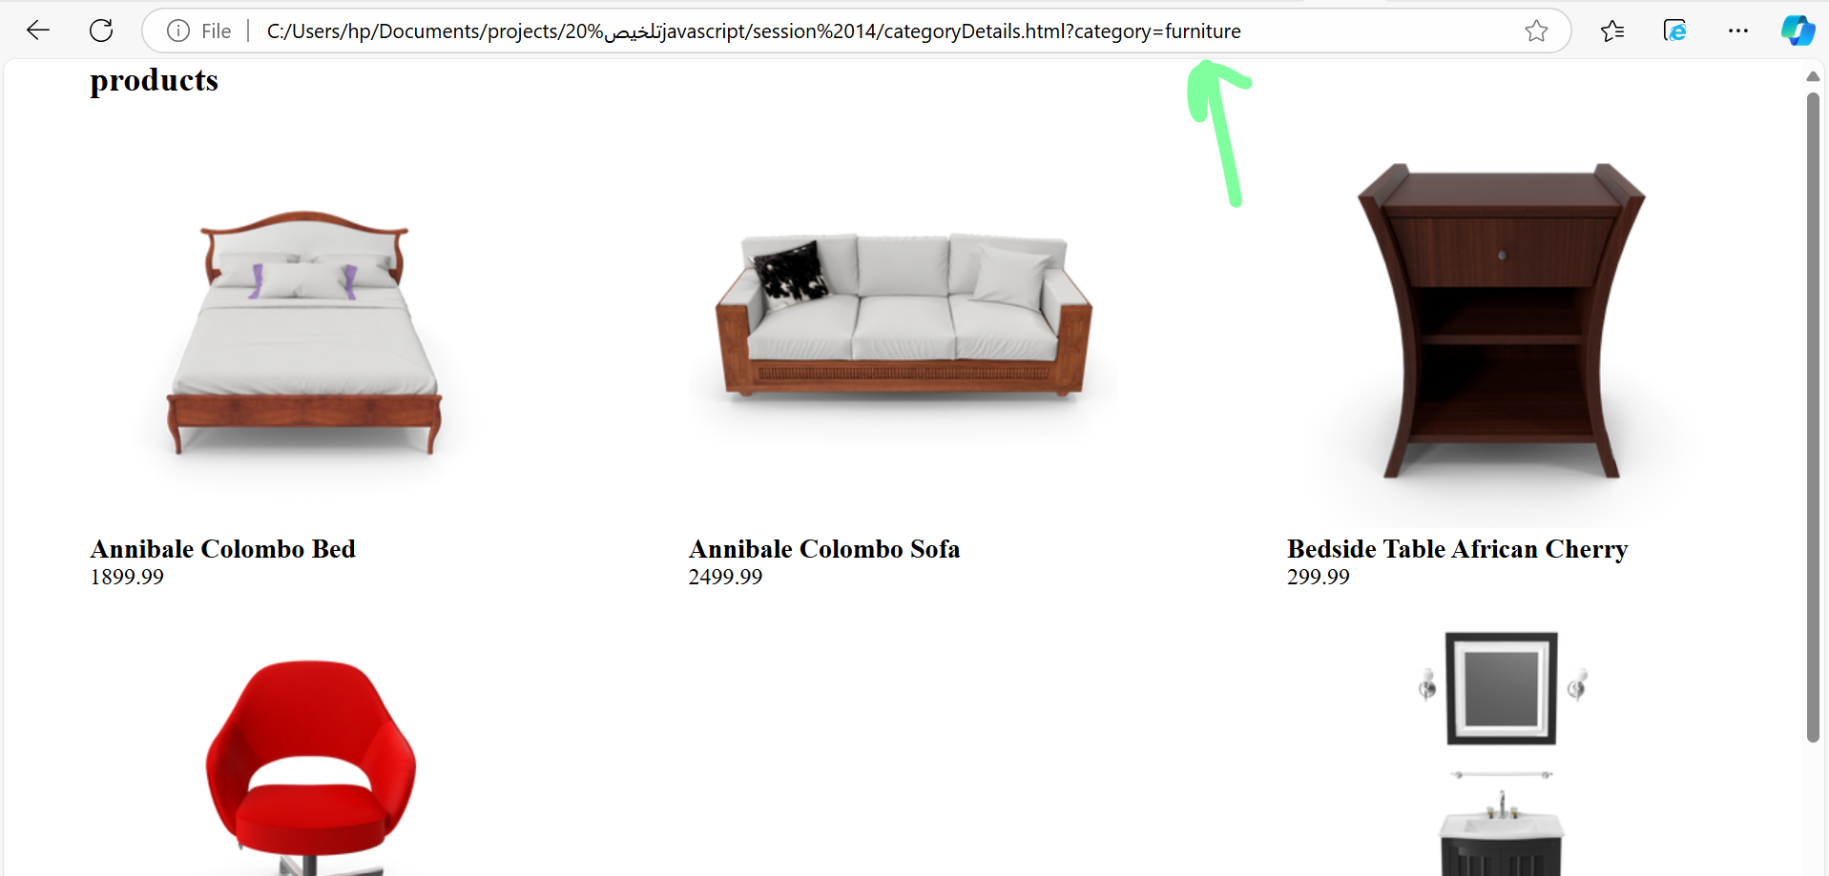

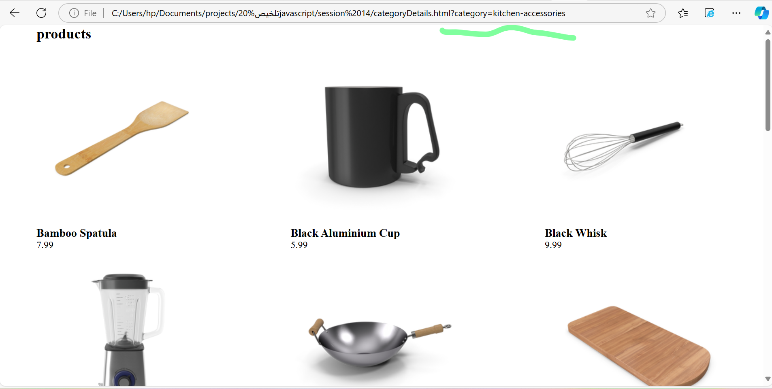

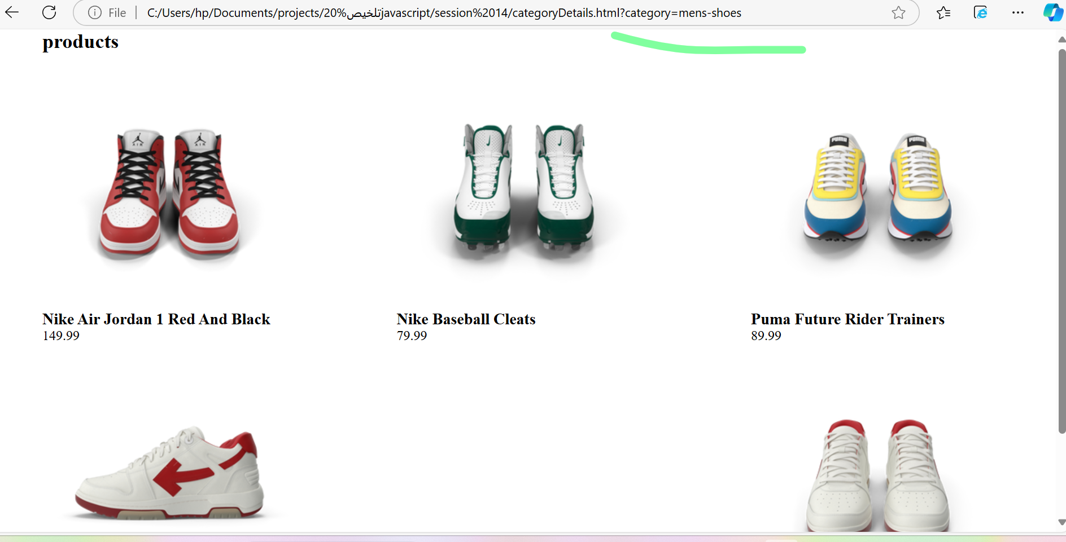

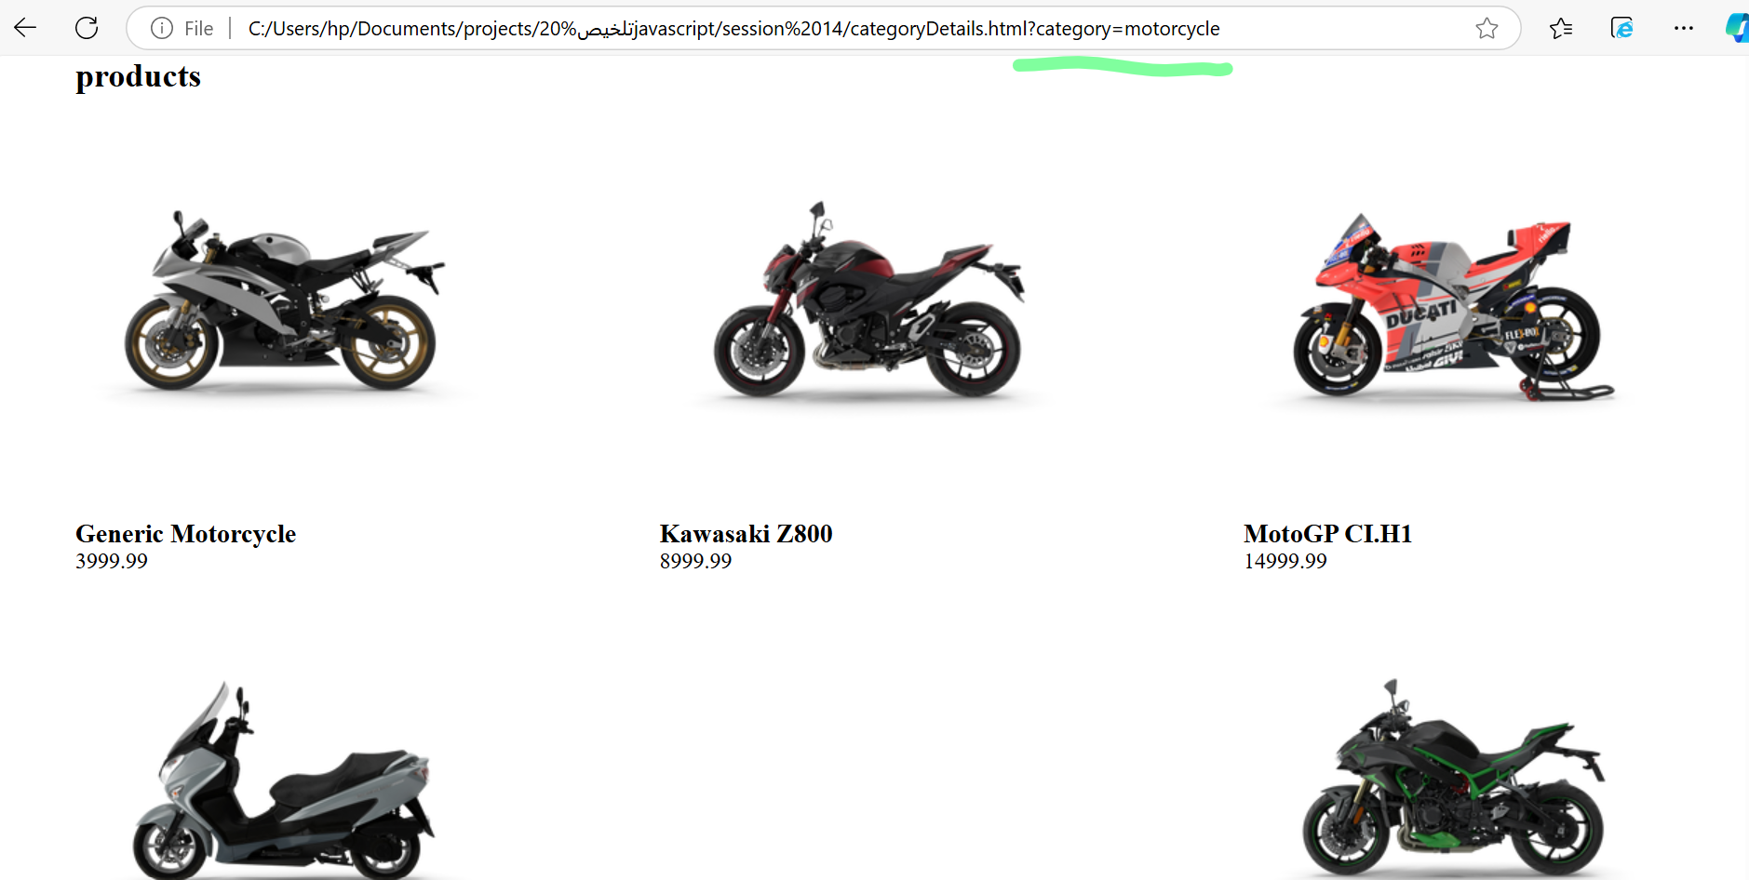

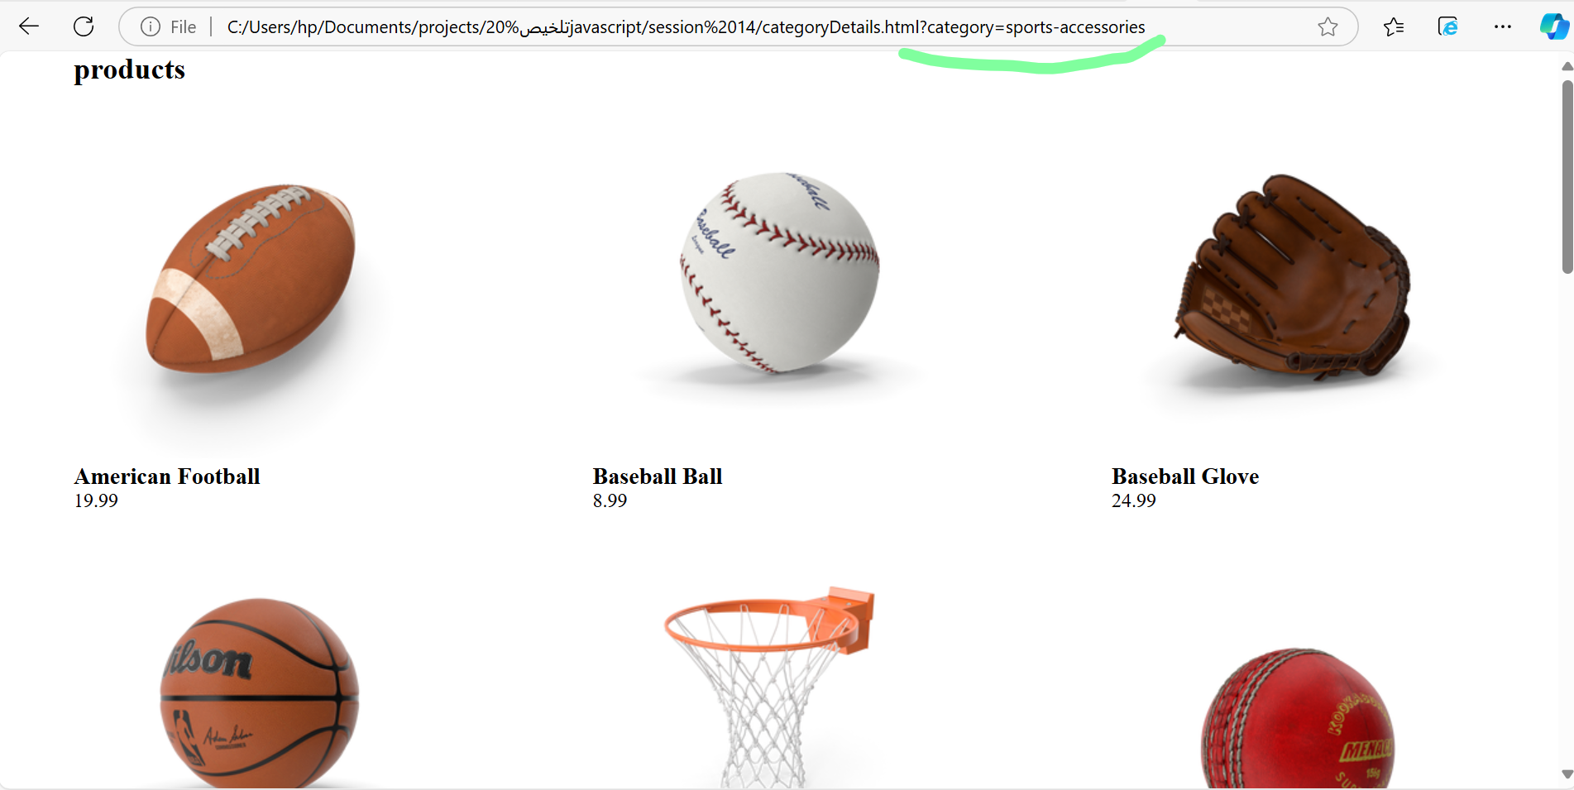

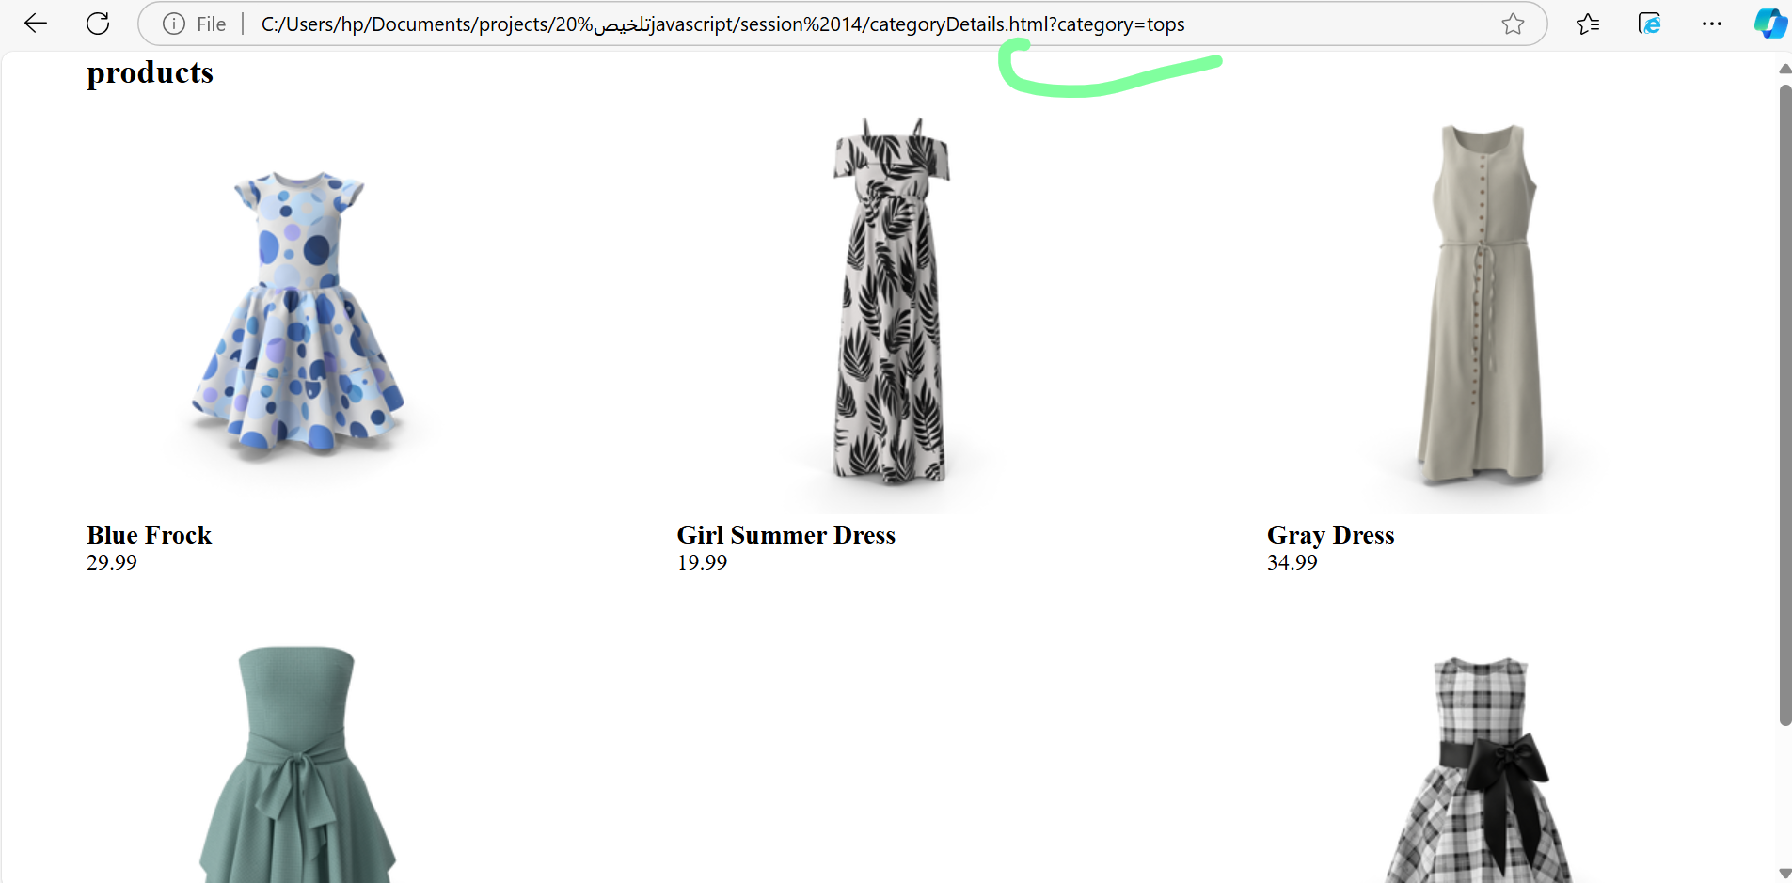

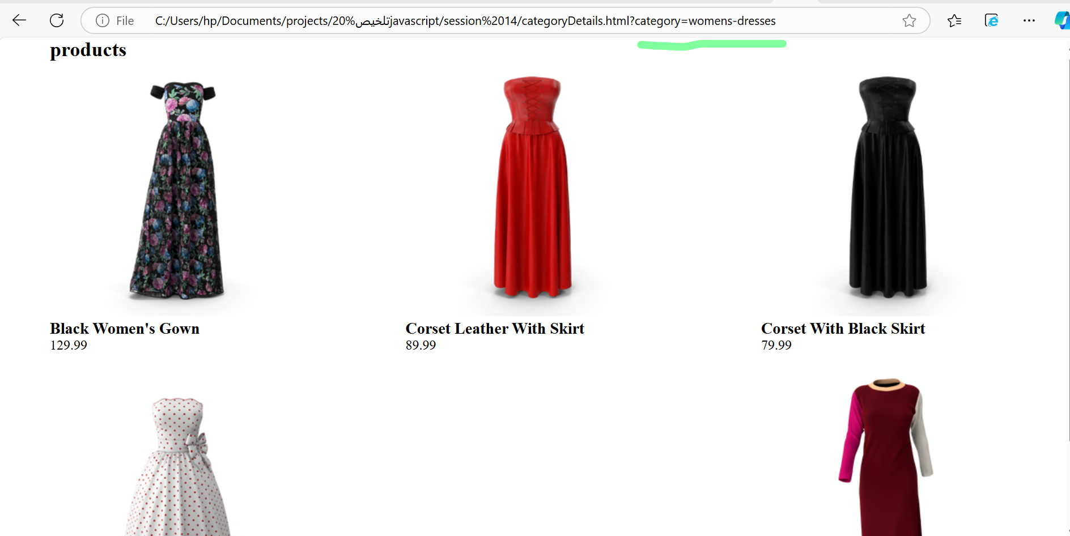

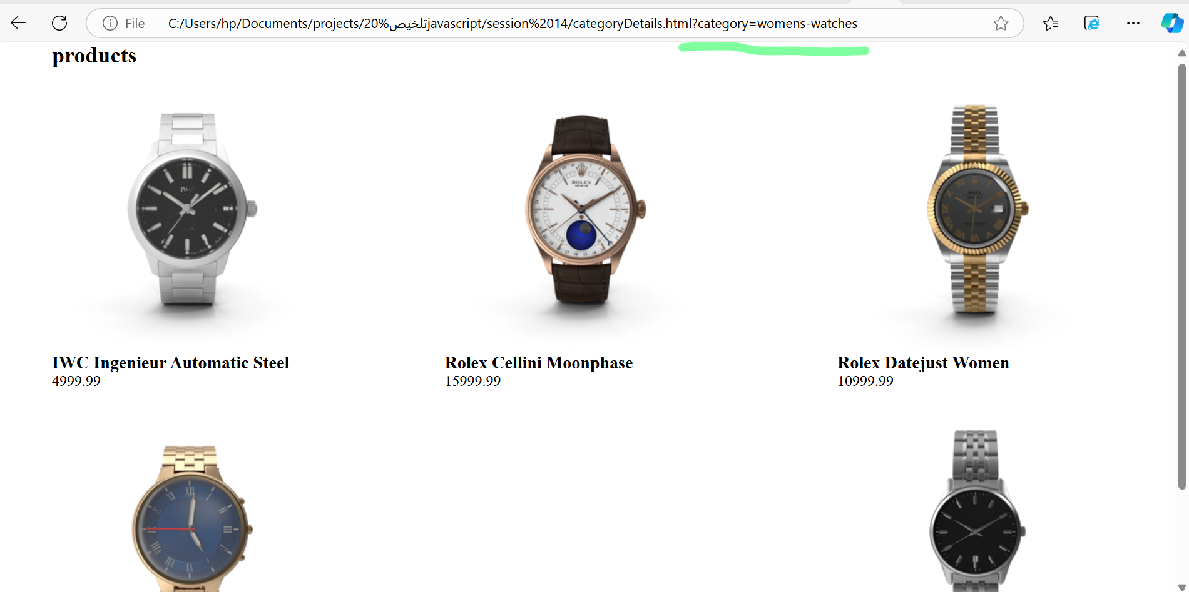

Link of category

[dummyjson.com/products/category-list?fbclid=IwY2xjawGUZo1leHRuA2FlbQIxMAABHYMC2Qn582y0CMjWBMt96S1FVZQ6G8_md9nXFOW5ly7lahXzMUFilqK9CQ_aem_TmPQB0aETlISLQ1MU0uYHQdummyjson.com/products/category-list?fbclid=IwY2xjawGUZo1leHRuA2FlbQIxMAABHYMC2Qn582y0CMjWBMt96S1FVZQ6G8_md9nXFOW5ly7lahXzMUFilqK9CQ_aem_TmPQB0aETlISLQ1MU0uYHQ](https://dummyjson.com/products/category-list?fbclid=IwY2xjawGUZo1leHRuA2FlbQIxMAABHYMC2Qn582y0CMjWBMt96S1FVZQ6G8_md9nXFOW5ly7lahXzMUFilqK9CQ_aem_TmPQB0aETlISLQ1MU0uYHQ)

link of product

[dummyjson.com/products](https://dummyjson.com/products)

link of DummyJSON

[Products - DummyJSON - Free Fake REST API for Placeholder JSON Data](https://dummyjson.com/docs/products)

[Get products by a category](https://dummyjson.com/docs/products#products-category)

fetch('https://dummyjson.com/products/category/smartphones')

.then(res => res.json())

.then(console.log);